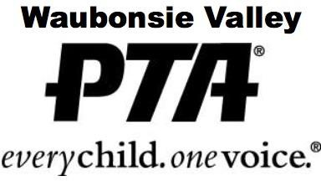

WVHS PTA

“EVERY STUDENT IS WORTHY” SCHOLARSHIP

In the spirit of the PTA’s mission of making every student’s potential a reality, the WVHS PTA has created a scholarship available to a larger portion of Waubonsie’s senior students. The eligibility requirements for this scholarship are simply that the student be a current WV senior in good standing, with an overall Weighted GPA between 2.00 and 3.00, and solid plans to continue their education beyond high school.

For the 2022-23 school year, the $1,000 scholarship will be chosen by a random drawing of all submissions and awarded at the annual WV Green and Gold Awards. The scholarship will be paid to the individual winner’s accredited college, university, or vocational/technical school that the student will be attending and must be utilized for educational expenses during the 2023-2024 school year.

Student Name

Student ID _

Overall GPA (Weighted)

Essay Questions:

- In a couple of sentences, briefly let us know your future plans:
- In a couple of sentences, what advice would you offer an incoming freshman?

