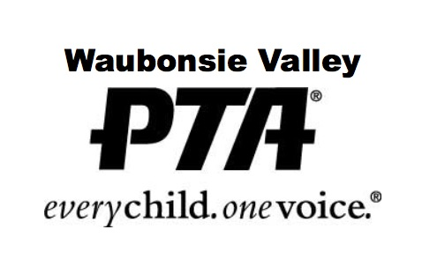

“EVERY STUDENT IS WORTHY” SCHOLARSHIP

In the spirit of the PTA’s mission of making every child’s potential a reality, the WVHS PTA has created a scholarship available to a larger portion of Waubonsie’s senior students. The eligibility requirements for this scholarship are simply that the student be a current WV senior in good standing, with a GPA between 2.5 and 3.6, and solid plans to continue their education beyond high school.

This $1,000 scholarship will be chosen by a random drawing of all submissions and awarded at the annual WV Green and Gold Awards.

Student Name ______________________________________________________

Student ID ———————————————————————————————

GPA _____________________________________________________________

In a couple of sentences, briefly let us know your future plans: _______________

__________________________________________________________________

__________________________________________________________________

__________________________________________________________________

__________________________________________________________________

